**Martin Wolf: coronavirus could be worst economic crisis since Great Depression**

<https://www.ft.com/video/fbaaa133-c94d-4e35-844b-bfde5f6a0635?playlist-name=latest&playlist-offset=1>

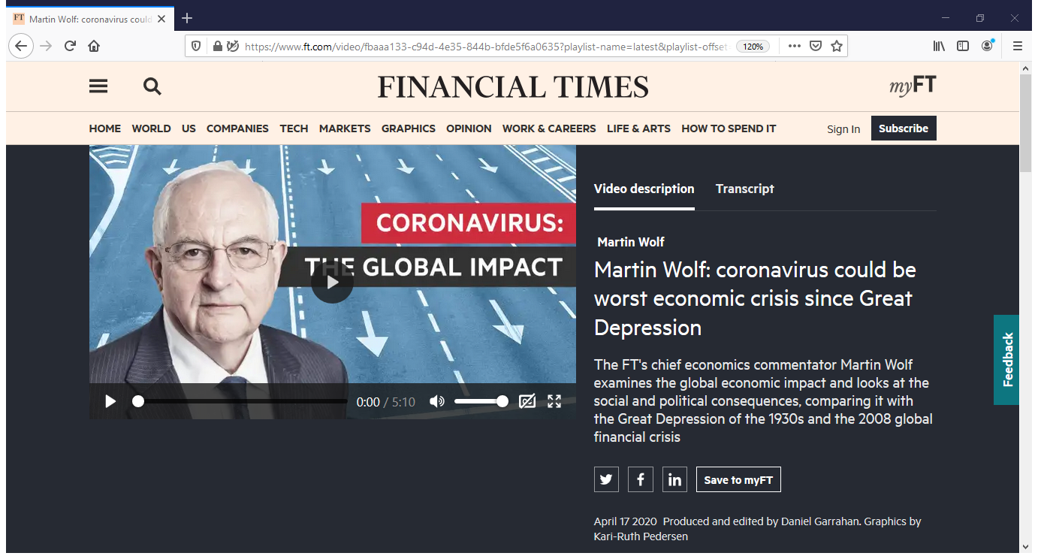

TRANSCRIPT OF FT-VIDEO

The really important issue is how much of our economy is destroyed in the process of managing the disease and how easily we can get back to normal. The optimistic view would be that we will bring the explosion that we have recently seen in cases and death under control. We will then have testing regimes available that allow us to keep it under control, so that within a relatively short time the major economies can follow China and begin to get back to work by the summer.

But at an extreme opposite it may be the case we simply cannot contain the disease. It might last till the end of 2021. If that were to happen, we'd obviously have colossal increases in public debt, maybe 20 or 30 percentage points of GDP. We would have many companies that have disappeared. We would have had many people who have been unemployed for a year and a half or more. We would have profound social unrest. I think the trading system would probably have collapsed. It could certainly be immediately, I think, in the short run, a bigger decline in output than in the early 1930s.

The impact on output gross domestic product in the developed countries will vary between minus 15 per cent and minus 30 per cent. So every month, as it were, our GDP will be smaller by that amount, below what it would have been if the crisis had never happened. And so over a year, that will be the shrinkage of GDP? And that's why you mustn't have it every year.

What the IMF is telling us is that we're going over an economic cliff right now. They're expecting that in advanced countries GDP will decline roughly by 12 per cent between the end of last year and the second quarter of this year. Thereafter, they hope, there will be a recovery. It will be a long time to get back to the starting point, but there will be a steady recovery. Unfortunately, even that could prove to be too optimistic.

If we look at what sectors are being hit, well, obviously it's travel, it's leisure, it's tourism, it's restaurants, it's retail. In the emerging developing countries there are no cushions of the type we have in the developed world, so their fate will be really much more like what happened in the '30s. This will be a truly profound transformation. Governments would be colossally indebted. They would have printed an enormous amount of money. I would expect serious inflation to emerge, one way or another.

If we were to do the very best one could imagine, the recession globally would still be worse than the Great Recession, not necessarily worse in the developed countries which were most directly hit by the 2007 or 2008 crisis. But it's very important to remember the 2007 and 2008 crisis wasn't really a global crisis. While the developed countries were badly hit and that affected the whole world, China did incredibly well, came out very, very quickly with an incredibly strong growth in 2009.

That supported commodities, and that meant a lot of emerging and developing countries did pretty well. Today, this is a global crisis. It's affecting every economy in the world, including China, of course, and all the emerging and developing countries, as well as the developed countries. If you think we are now in 1930, as it were, we're going over a cliff faster than in 1930.

It's more global than in 1930. And if it goes like this for two or three years, then I think political consequences which, ultimately, will feed back into the economy are just wildly unpredictable and could be devastating. Without the Great Depression, Adolf Hitler would never have been elected to power in Germany.

It is possible, if we get the disease under control, that the recovery will be quicker. We're going to have to have higher taxation to strengthen our health systems, and I think we'll have to strengthen our social safety nets. And those costs will have to be borne by the relatively well-off.

We will have to consider whether we can continue with gig working, precarious working. We will have to rethink how we relate the winners to the losers in our economic system. Otherwise, I don't believe our democratic systems will survive.